CHANGES: HOME PAGE
Instead of black theme, go with White and red theme as I shared the sample reference website in whatsapp , Attaching here as well:

- Background image needs to tell our service directly – Im attaching one photo below – you take the kind of image
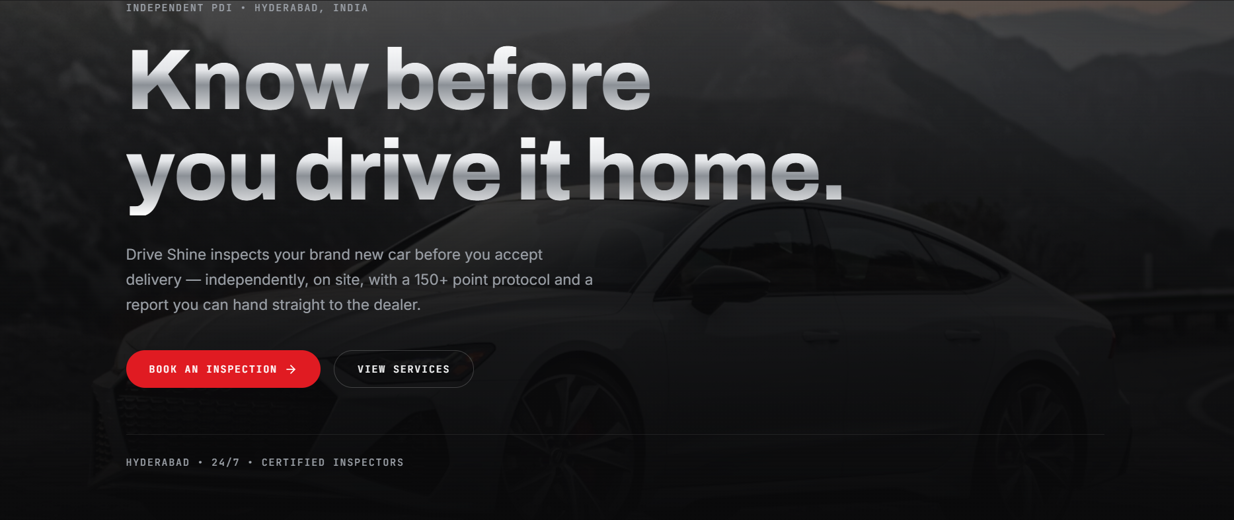

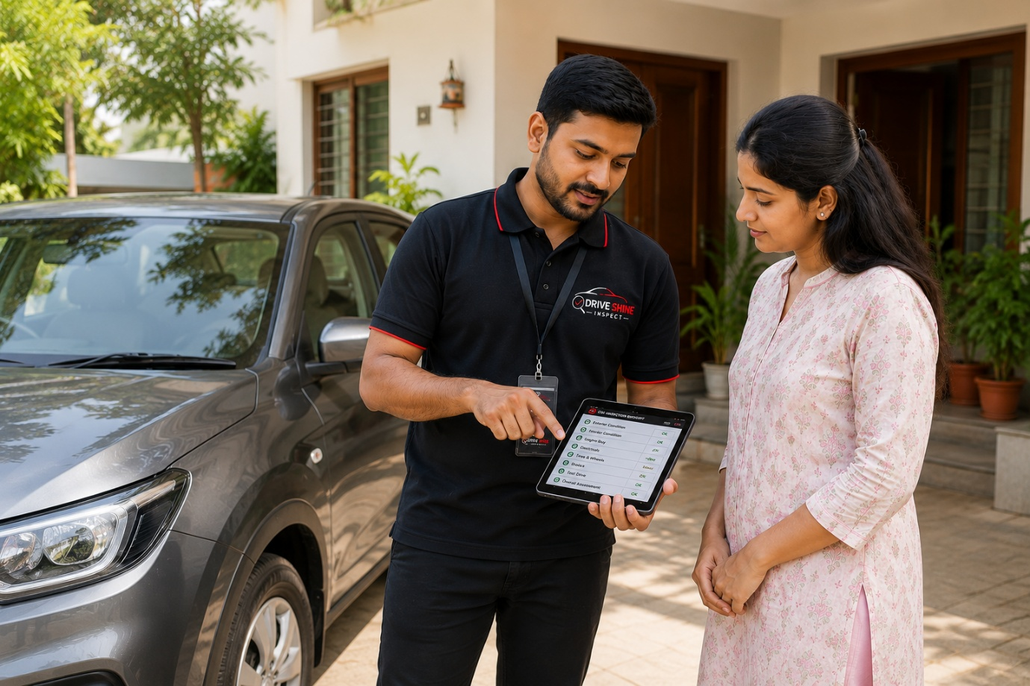

You didn’t add individual price list

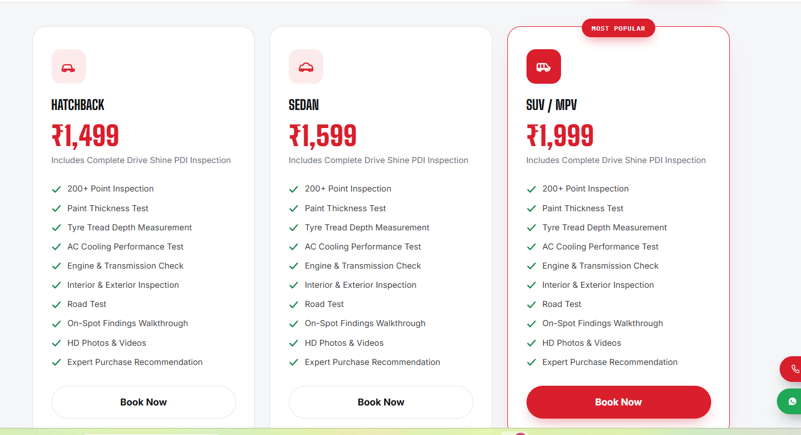

2.Right now we are not giving any report, so better not highlight report things anywhere through out the portal


8+ Years experience, Report thing not need – basically within 30-45min it will done so don’t highlight time
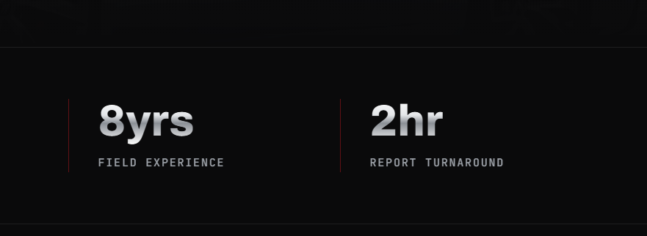

- Below 3 photos are highlighted more – as we are using professional tools for the inspection for both used cars and new cars
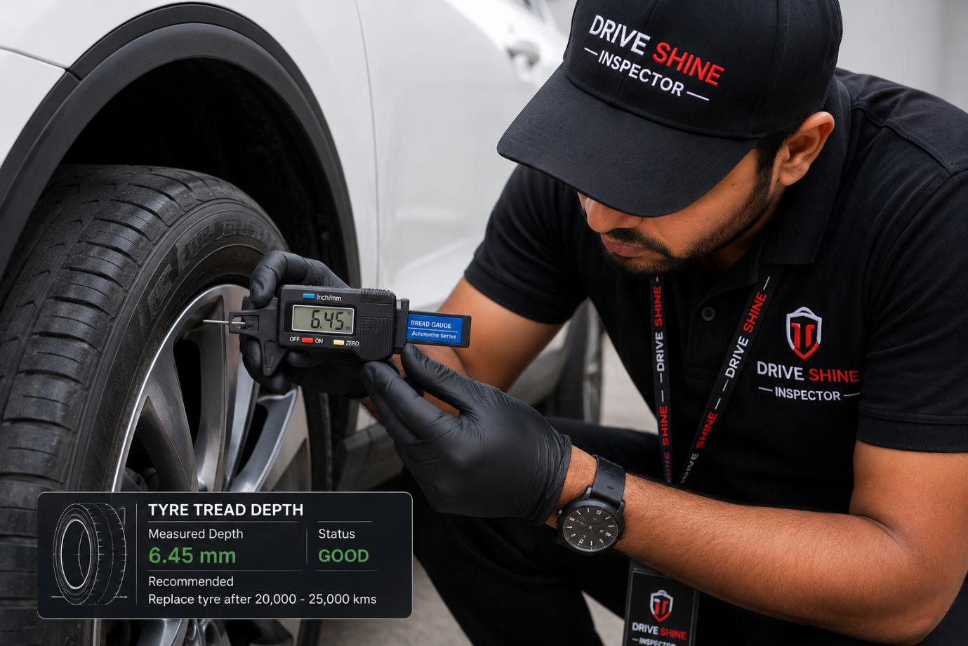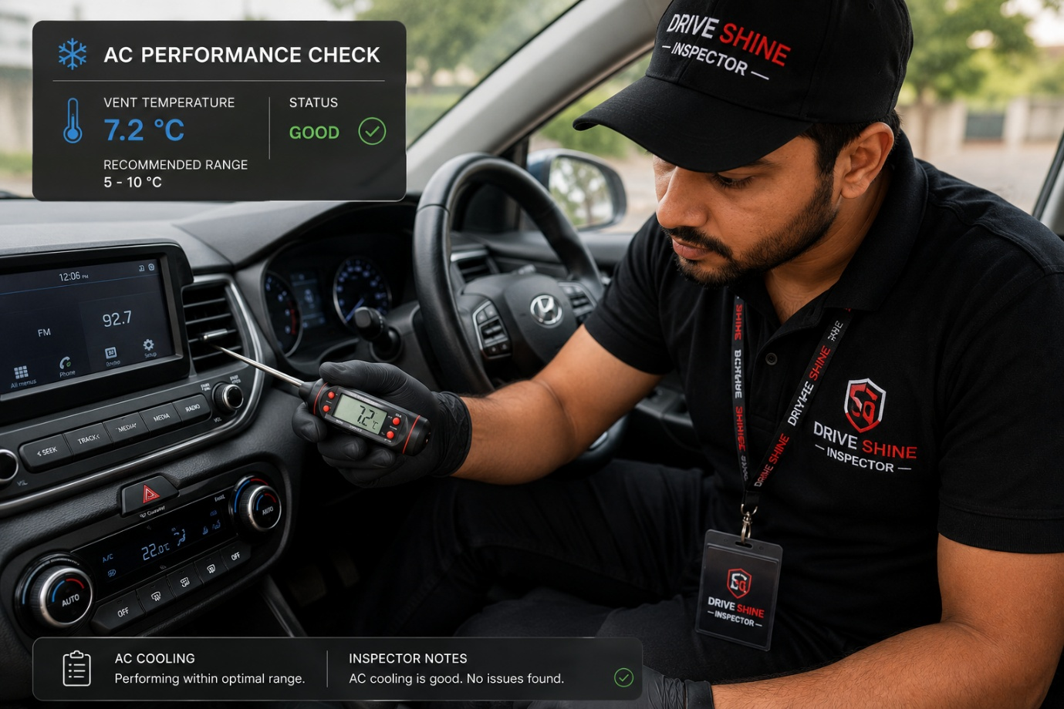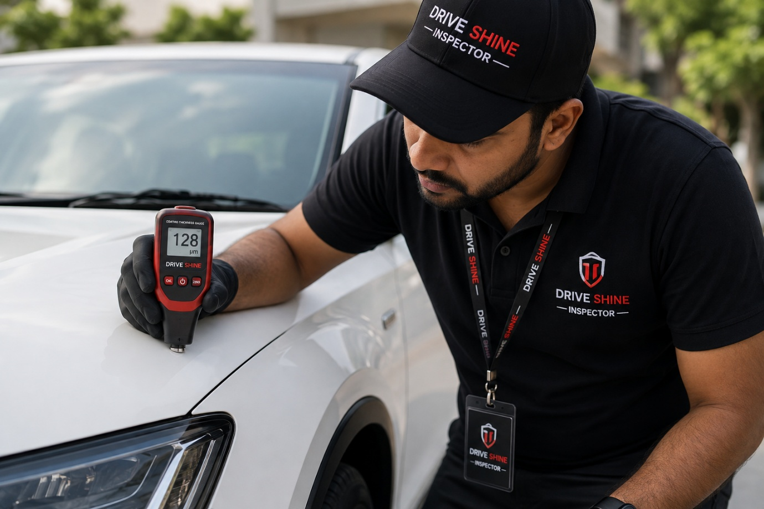

- Not only paint depth , Ac temperature , Tyre Tread Depth Gauge
- 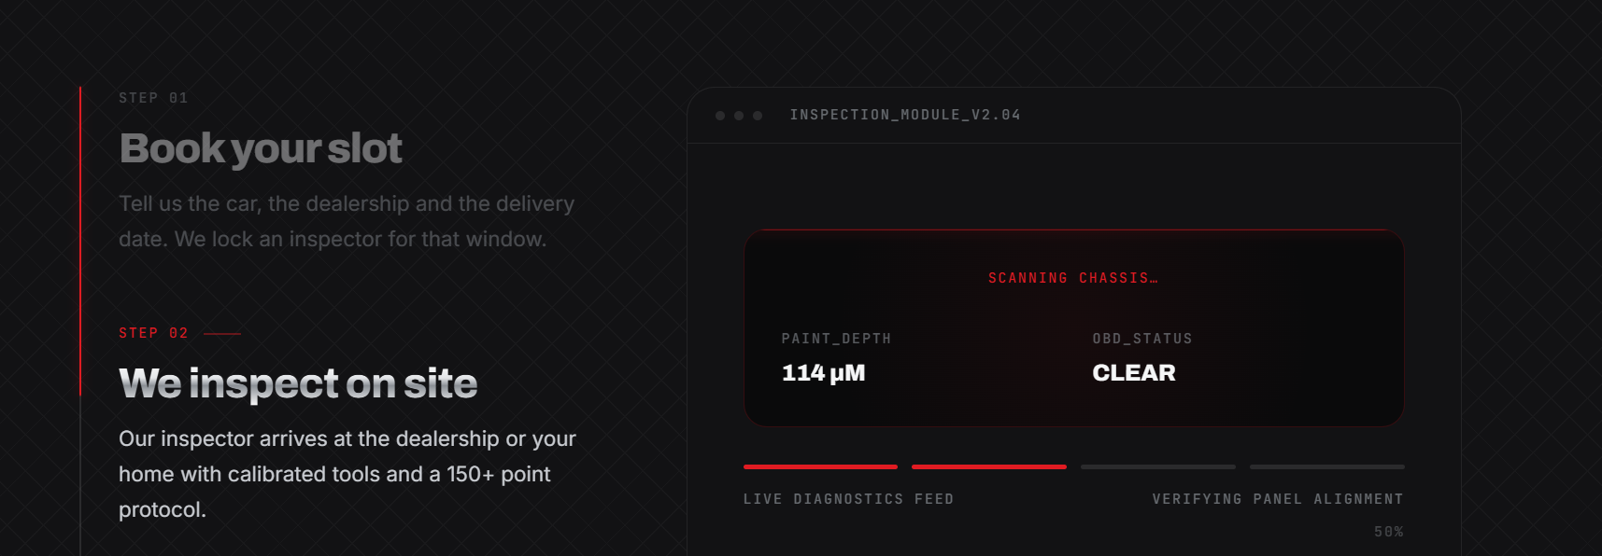

And highlight these:
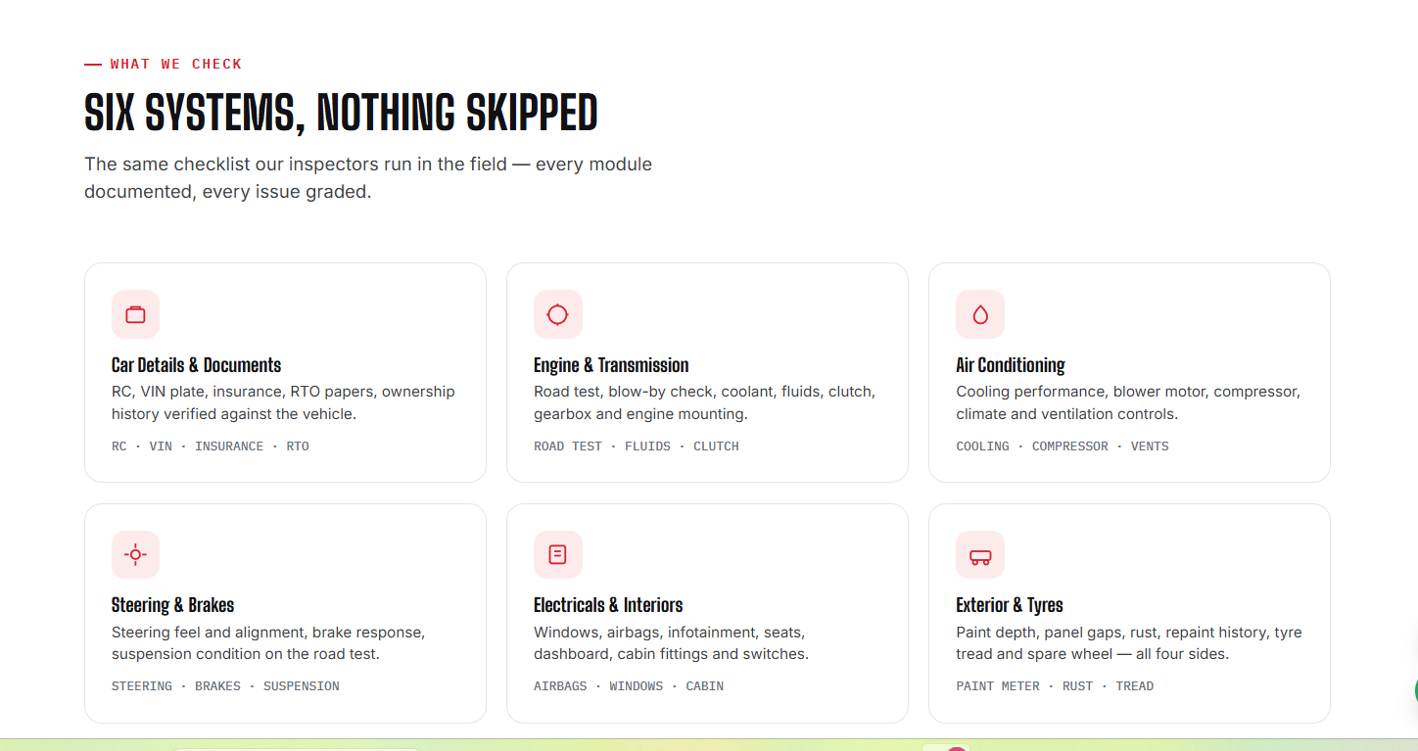

6 .Don’t mention photos thing 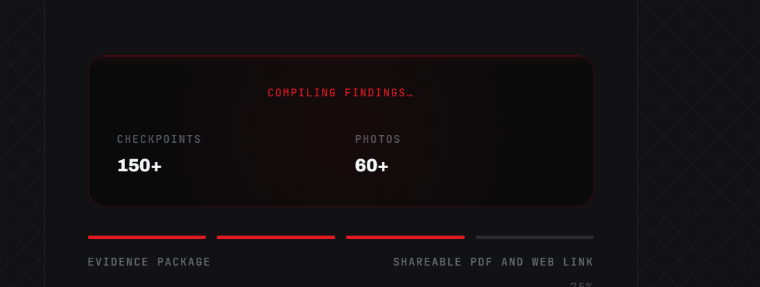
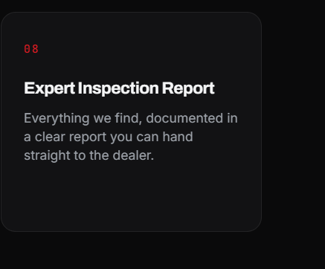
Remove this image and replace it the image which I have shared : Drive shine inspector with lady below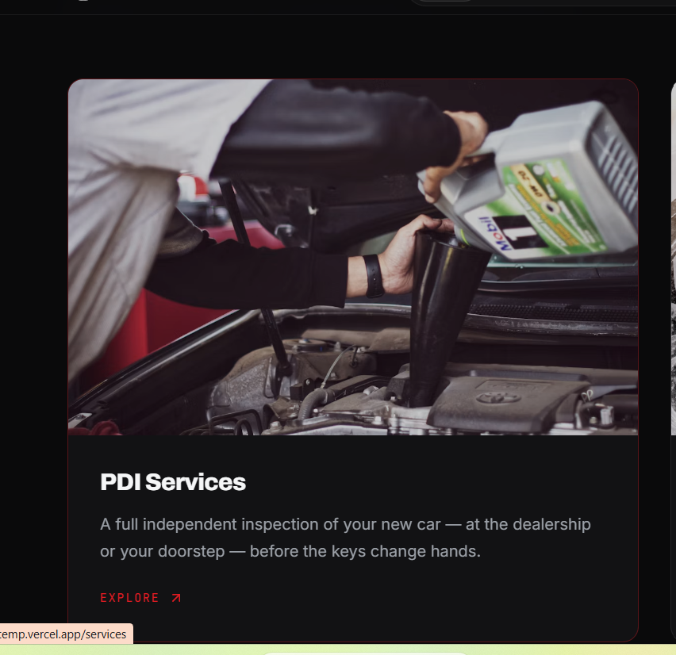



7.Remove Report things :


8. We are not giving OBD service , Hope you have gone through the which shared by Harshith on group – drive shine reference website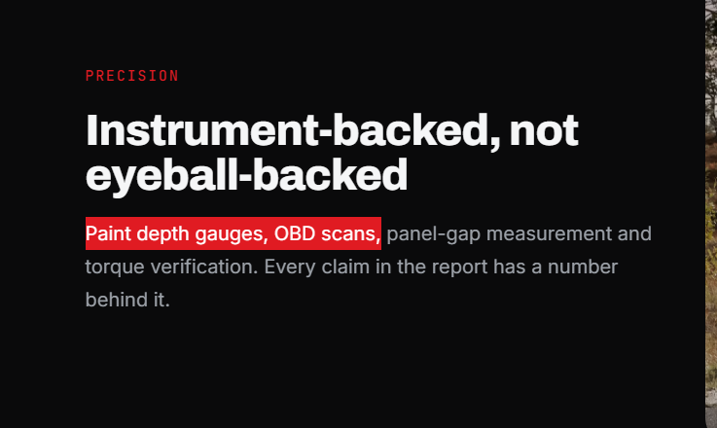

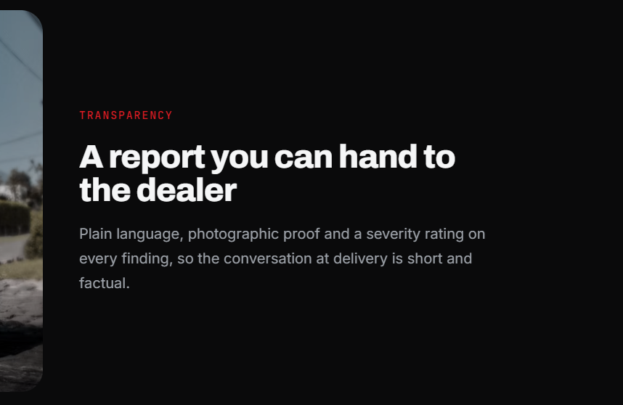
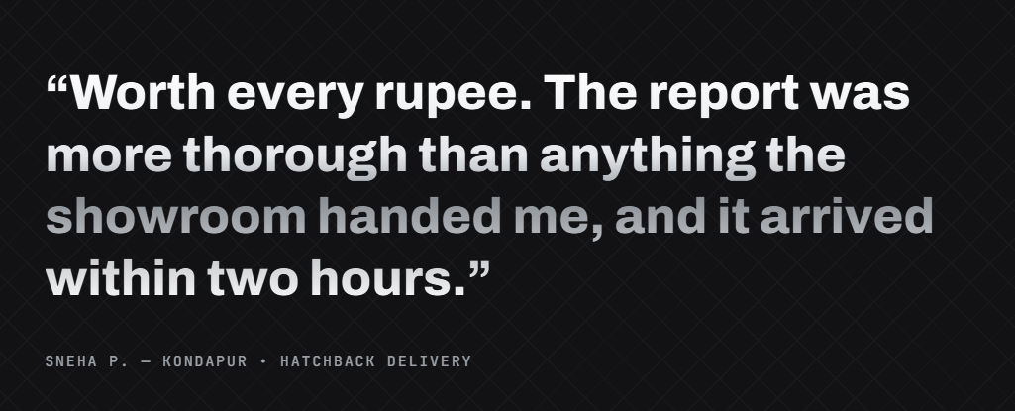

Whats app and number should highlight in corner thtoughout the page
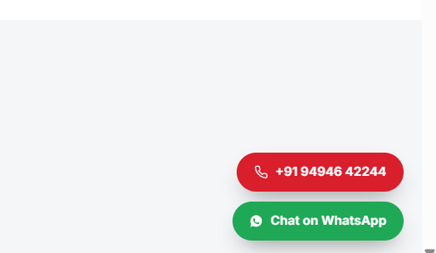

Location or place which ever seems professional has to be added: 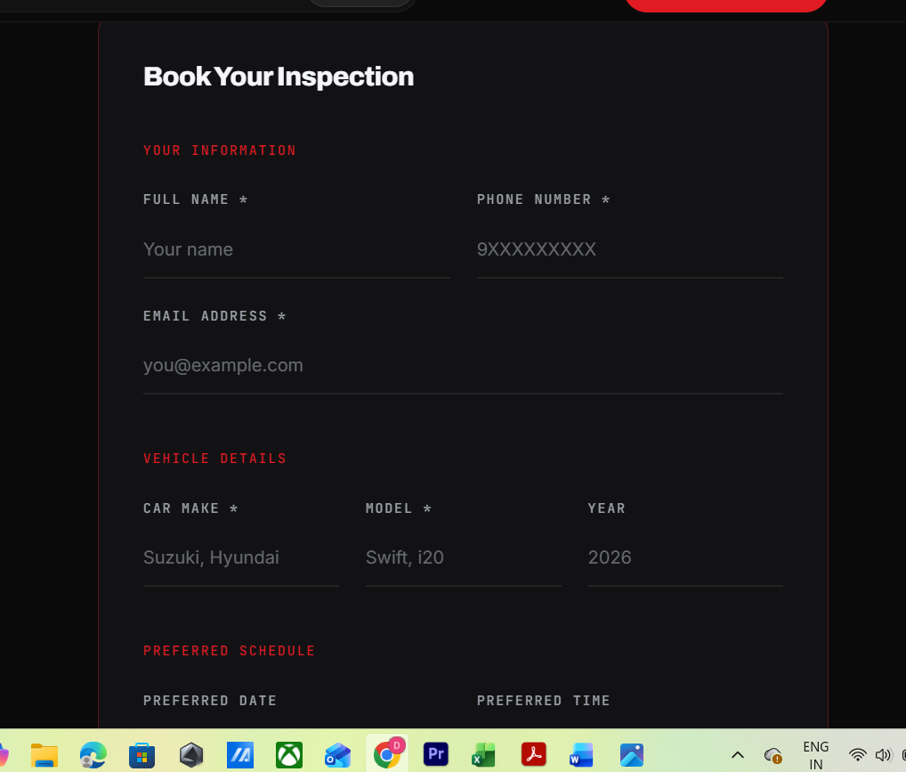

Services Page
1.We also do PDI for pre-owned cars aswell – no where you have mentioned that

- And for the amazon products I will give you the links you can add it accordingly and photos Aswell I will provide

- In below images replace tyre polish with Windshield Washer and all below 3 s coming soon 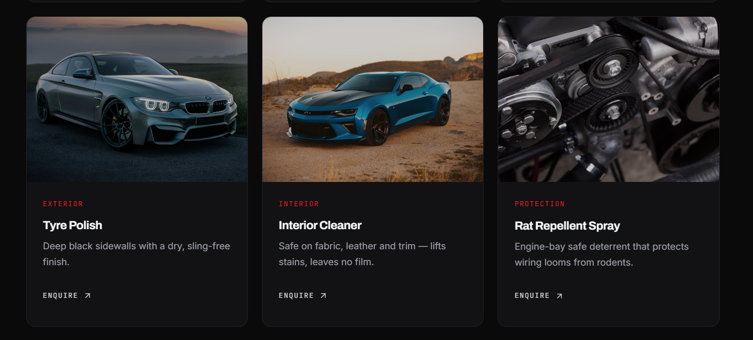

4.Car shampoo , Glass cleaner , Dashboad polish I will share the amazon links – so when the user click on the shop on amazon it will route to amazon products – check the reference
